AMS 333 HW# 1

Ivan Tinov

110255332

**Question 1:**

1. **on rectangular (linear) coordinates:**

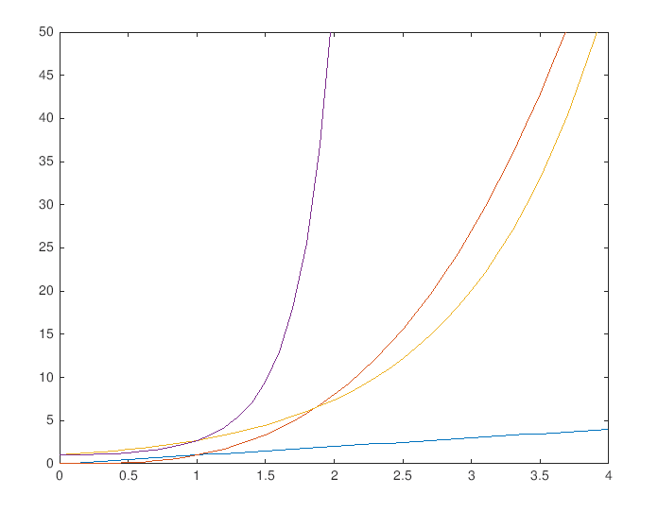

Code for part a:

x = (0:0.1:4); % interval

y = (0:0.1:4);

f1 = x;

f2 = x.^3;

f3 = exp(x);

f4 = exp(x.^2);

% plot functions

plot(x, f1);

hold on;

plot(x, f2);

plot(x, f3);

plot(x, f4);

ylim([0 50]);

hold off;

1. **on semilog scale (logarithm on the y-axis)**

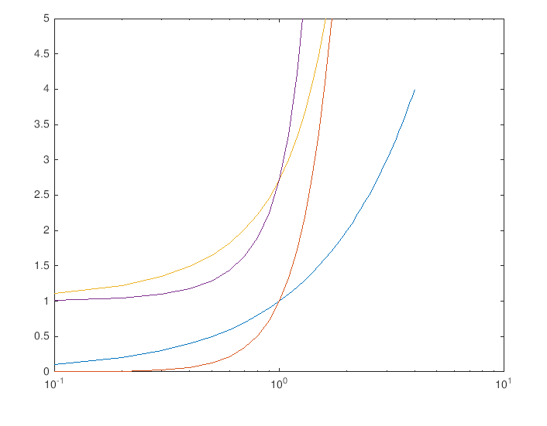

Code for part b:

x = (0:0.1:4); % interval

f1 = x;

f2 = x.^3;

f3 = exp(x);

f4 = exp(x.^2);

% semilogx functions

semilogx(x, f1);

hold on;

semilogx(x, f2);

semilogx(x, f3);

semilogx(x, f4);

ylim([0 5]);

hold off

1. **on log-log scale**

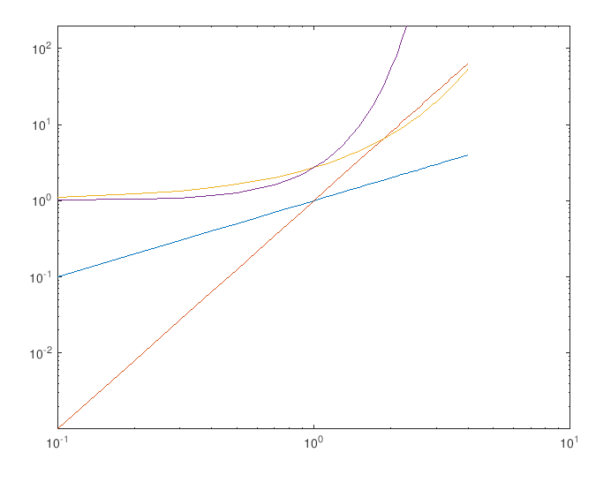

Code for part c:

x = (0:0.1:4); % interval

f1 = x;

f2 = x.^3;

f3 = exp(x);

f4 = exp(x.^2);

% loglog functions

loglog(x, f1);

hold on;

loglog(x, f2);

loglog(x, f3);

loglog(x, f4);

ylim([0 200]);

hold off;

**Question 2:**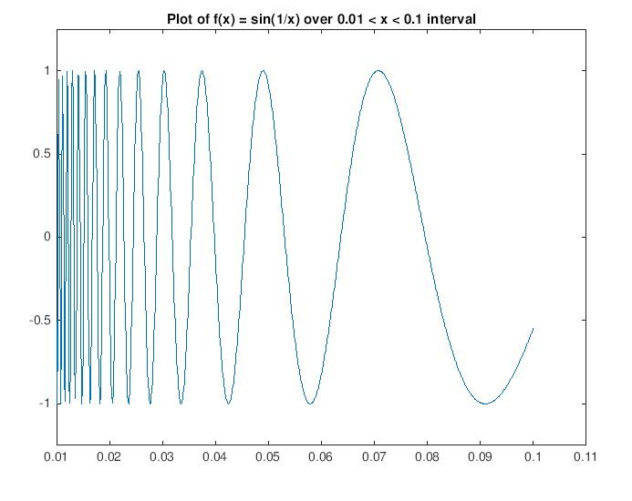

Code for question 2:

x = 0.01:0.0001:0.1;

f = sin(1./x);

plot(x, f);

ylim([-1.25 1.25]);

title('Plot of f(x) = sin(1/x) over 0.01 < x < 0.1 interval');

**Question 3:**

Output below produces desired result of 949.50.

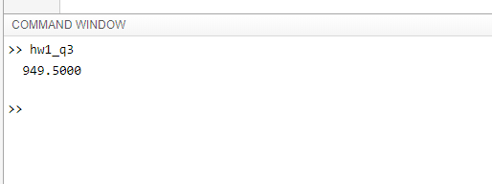

Code for question 3:

T = 110; % produces 949.5

% T = 5; produces -5

if (T > 0 && T < 100)

h = T - 10;

disp(h);

elseif(T > 100)

h2 = 0.45*T + 900;

disp(h2);

end

**Question 4:**

Testing values of 5, -5, and 0 or basically any positive, negative values will bring out the desired sign. Zero will always give 0.

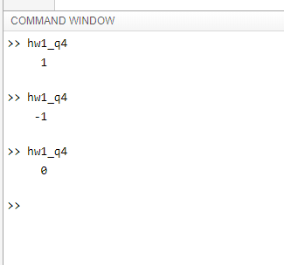

Code for question 4:

% testing with sign function here:

% x = sign(5);

% disp(x)

x = 0; % testing variables here 5, -5, 0 (+,-,0)

if (x < 0)

f = -1; % negative

disp(f);

elseif (x == 0)

f = 0; % neutral 0

disp(f);

elseif (x > 0)

f = 1; % positive

disp(f);

end

**Question 5:**

Randomized output for question 5 below.

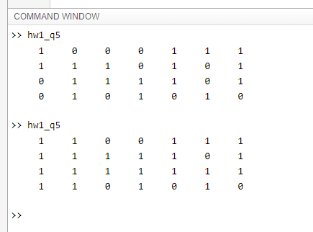

Code for question 5:

arr = rand(4,7);

[M,N] = size(arr);

for i = 1:M

for j = 1:N

if (arr(i,j) < 0.2)

arr(i,j) = 0;

else

arr(i,j) = 1;

end

end

end

disp(arr);

**Question 6:**

Parts a thru e results are displayed here.

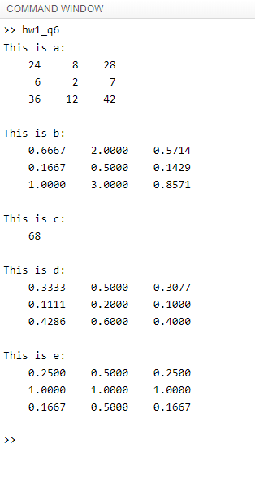

Code for question 6:

x = [4 1 6];

y = [6 2 7];

N = length(x);

for j = 1:N

c(j) = x(j)*y(j);

for k = 1:N

a(j,k) = x(j)*y(k);

b(j,k) = x(j)/y(k);

d(j,k) = x(j)/(2 + x(j) + y(k));

e(j,k) = 1/min(x(j),y(k));

end

end

c = sum(c); % or use 1.a. loop

disp('This is a: ');

disp(a);

disp('This is b: ');

disp(b);

disp('This is c: ');

disp(c);

disp('This is d: ');

disp(d);

disp('This is e: ');

disp(e);

**Question 7:**

1. **The number of random numbers it takes to add up to 20 (or more).**

Results:

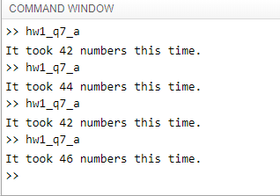

Histogram: 46 numbers

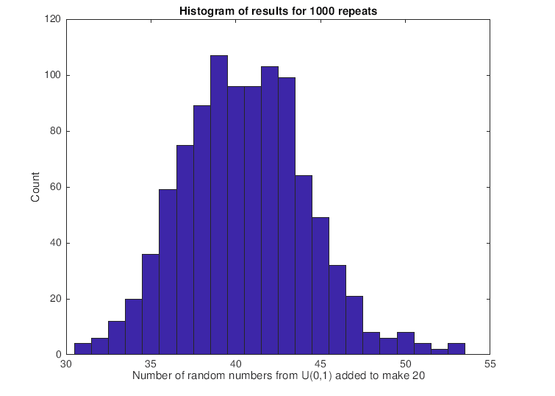

Code for part a:

total = 0;

count = 0;

while total < 20 % loop until 20

count = count + 1;

x = rand(1,1);

total = total + x;

end

disp(['It took ',int2str(count),' numbers this time.'])

Nrep = 1000;

count = zeros(Nrep,1);

for j = 1:Nrep

total = 0;

while total < 20

count(j) = count(j) + 1;

total = total + rand(1,1);

end

end

hist(count,min(count):max(count))

xlabel('Number of random numbers from U(0,1) added to make 20')

ylabel('Count')

title(['Histogram of results for ',int2str(Nrep),' repeats'])

1. **The number of random numbers it takes before a number between 0.8 and 0.85 occurs.**

Results:

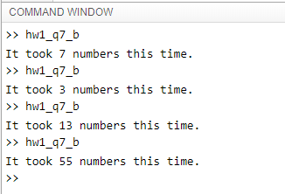

Code for part b:

count = 0;

while 1 % infinite loop

count = count + 1;

x = rand(1,1);

if (x < 0.85) && (x > 0.8) % check val

break

end

end

disp(['It took ',int2str(count),' numbers this time.'])

1. **The number of random numbers it takes before the mean of those numbers is within 0.01 of 0.5 (the mean of this random-number generator).**

Results:

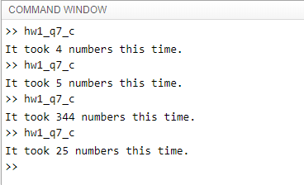

Code for part c:

count = 0;

avg = 0;

while abs(avg - 0.5) > 0.01

count = count + 1;

% (count-1) * avg is sum of the first count-1 numbers.

% Rand just adds another number.

% Dividing by count then gives new average.

avg = ((count-1)*avg + rand(1,1))/count;

end

disp(['It took ',int2str(count),' numbers this time.'])

**Question 8:**

**Part a:**

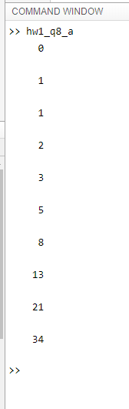

Code for part a:

% part a

f(1) = 0;

f(2) = 1;

disp(f(1));

disp(f(2));

for i = 3:10

f(i) = f(i-1) + f(i-2);

disp(f(i));

end

**Part b:**

Output:

hw1_q8_b

1 1 1  
2 1 2  
3 2 1.5  
5 3 1.666666667  
8 5 1.6  
13 8 1.625  
21 13 1.615384615  
34 21 1.619047619  
55 34 1.617647059  
89 55 1.618181818  
144 89 1.617977528  
233 144 1.618055556  
377 233 1.618025751  
610 377 1.618037135  
987 610 1.618032787  
1597 987 1.618034448  
2584 1597 1.618033813  
4181 2584 1.618034056  
6765 4181 1.618033963  
10946 6765 1.618033999  
17711 10946 1.618033985  
28657 17711 1.61803399  
46368 28657 1.618033988  
75025 46368 1.618033989  
121393 75025 1.618033989  
196418 121393 1.618033989  
317811 196418 1.618033989  
514229 317811 1.618033989  
832040 514229 1.618033989  
1346269 832040 1.618033989  
2178309 1346269 1.618033989  
3524578 2178309 1.618033989  
5702887 3524578 1.618033989  
9227465 5702887 1.618033989  
14930352 9227465 1.618033989  
24157817 14930352 1.618033989  
39088169 24157817 1.618033989  
63245986 39088169 1.618033989  
102334155 63245986 1.618033989  
165580141 102334155 1.618033989  
267914296 165580141 1.618033989  
433494437 267914296 1.618033989  
701408733 433494437 1.618033989  
1134903170 701408733 1.618033989  
1836311903 1134903170 1.618033989  
2971215073 1836311903 1.618033989  
4807526976 2971215073 1.618033989  
7778742049 4807526976 1.618033989

Code for part b:

% part b

f(1) = 0;

f(2) = 1;

% create the first 50 fibonacci numbers

for i = 3:50

f(i) = f(i-1) + f(i-2);

golden_ratio = f(i)/f(i-1);

str = [num2str(f(i)) ' ' num2str(f(i-1)) ' ' num2str(golden_ratio, 10)];

disp(str)

end

**Question 9:**

Results for a thru e are displayed below:

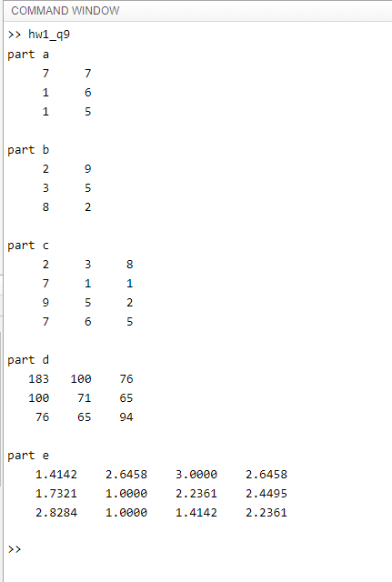

Code for question 9:

A = [2 7 9 7 ; 3 1 5 6 ; 8 1 2 5];

% a)

B=[A(:,2) A(:,4)];

disp('part a');

disp(B);

% b)

C=[A(:,1) A(:,3)];

disp('part b');

disp(C);

% c)

D=A';

disp('part c');

disp(D);

% d)

E=A*D;

disp('part d');

disp(E);

% e)

disp('part e');

disp(sqrt(A));

**Question 10:**

Results for parts a thru d are displayed below:

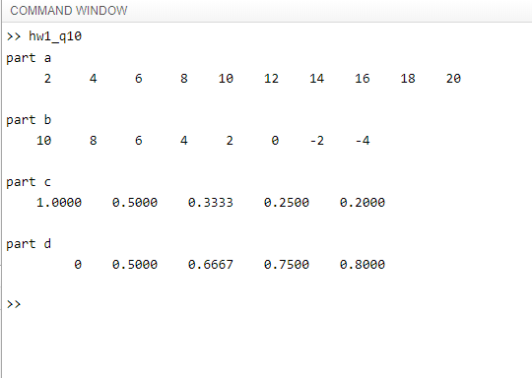

Code for question 10:

% a)

disp('part a');

a = 2:2:20;

disp(a);

% b)

disp('part b');

b = 10:-2:-4;

disp(b);

% c)

disp('part c');

c1 = 1:5;

c2 = 1./c1;

rats(c2);

disp(c2);

% d)

disp('part d');

d1 = 0:4;

d2 = 1:5;

d3 = d1./d2;

rats(d3);

disp(d3);

**Question 11:**

Results for question 11:

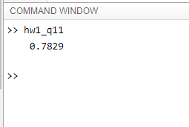

Code for question 11:

n = 1:100;

x = ( (-1).^(n+1) ) ./ (2*n - 1);

y = sum(x);

disp(y)